**Joint Second Prize**

**Entry in Chinese**

**Suchao Li**

**Summoning the Souls of Gwangju — The Former Gwangju Armed Forces Hospital as Art Site**

“Imagined Borders” — the ‘GB Commission’

Gwangju

2018

As part of a new extension program commissioned for the 2018 Gwangju Biennale “Imagined Borders” — the ‘GB Commission’ — an abandoned military hospital (the former “Armed Forces’ Gwangju Hospital”) became a satellite site of the biennale, alongside the main exhibition venues. During the “May 18th Democratization Movement” [translator’s note: also known as the Gwangju Uprising] in 1980, this place was used as a military hospital, and citizen protesters who were victims of the military crackdown during the democracy movement were taken here for ‘treatment’. Protesters who were diagnosed as having ‘mental illnesses’ were also brought here. Since the hospital moved elsewhere and the building was closed in 2007, it has been abandoned for more than a decade.

Today, the hospital’s white two-storey building survives, but the interior has long since been deserted, and the building is surrounded by wild grass and weeds. Indoors, under the dim lighting, you can see the pockmarked walls and ceiling stretching away down the long corridor towards the interior of the building, until they eventually vanish into the darkness. Rows of rooms line each side of the corridor; these used to be wards, bathrooms, toilets, or cells for interrogating patients. The floor is covered in glass from the smashed window panes; the old window frames, the exposed water pipes and electric wires, the broken wash basins and urinals, the toilet cubicles with half-height doors, the desolate grove of trees outside the window — it’s a sight which could well remind you of a scene from that Korean horror movie “*Gonjiam:* Haunted Asylum”, which was quite popular a few years ago. When you stand here, it’s as though you can sense the patients who once lived here, as if they are still wandering throughout the hospital, like phantoms who refuse to go away. This place, which played such an important role in the Gwangju uprising, has become a leftover fragment of South Korea’s democratization movement. It’s as though the Gwangju events have left behind a scar, branded on the city.

Precisely because of its commemorative significance, the Gwangju Biennale, in its 12th edition last year, went back to its roots and turned its focus onto Gwangju’s history, exposing the city’s scars to the world in the name of art. The British artist Mike Nelson, the French artist Kader Attia and the Thai artist and experimental film director Apichatpong Weerasethakul accepted the Biennale’s commission, and each created a site-specific installation in this hospital.

In the chaotic political atmosphere of those days, the hospital chapel, situated at the end of a little path in the wood, provided a place of spiritual refuge for the hospital’s patients and medical staff. It has been abandoned for many years, but Nelson’s work “*Mirror Reverb”* converts it into a three dimensional space filled with multiple layers of reflections: mirrors of all shapes and sizes are suspended from the ceiling, reflecting the scene in the room, the light from outside and each visitor, from every possible angle. Based on his research into the hospital, the artist, who is skilled at uncovering the distinctive qualities of his materials, has gathered discarded items from the hospital and the chapel itself, including mirrors and the plywood boards used to support them, and reorganized them into this installation piece. These previously abandoned materials now play the role of witnesses to history: in the disused chapel building, they have composed a new melody, and the vision of the past that can be seen here has been restored to its place in the temporal link between history and the present.

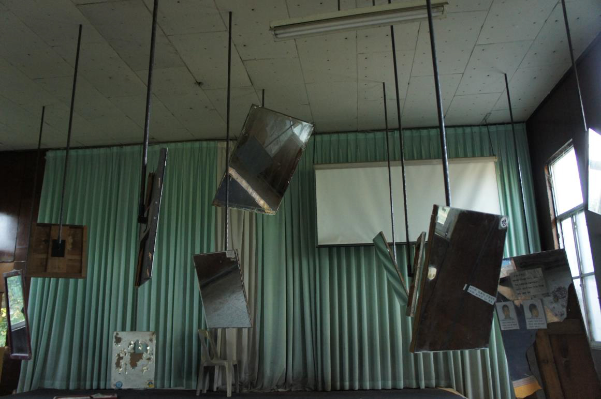

Mike Nelson, *Mirror Reverb*, 2018 (Photograph by the author)

The impact of historical and social injustice of various kinds has formed the underlying concept of the work of the French artist of Algerian heritage Kader Attia. The work “*Eternal Now*” is his memorial for the trauma which the Republic of Korea experienced during its modern democratization process. “Collective trauma is the spectre of all modernity” — Attia attempts to ‘repair’ the scars which time brings to living things and all objects: these may be cracked teacups, floorboards split open, fractured wooden beams… The artist believes that “if you try to repair individual or collective trauma, you have to accept the very real chance that it may be impossible for them to heal.” In this work, Attia inserts metal staples into a series of damaged wooden beams. These tiny metal objects, which can’t be removed, are stapled onto the ‘wound’, and this process of repairing becomes a part of the wound itself, giving a new life to these injured objects.

Exposing and facing up to trauma also means facing up to the history that lies behind it. Even if it undergoes repairs, it’s also impossible to return it completely to its original state. The fractured beams and the metal staples are like two parts of a wounded body: the former point towards the time when the trauma occurred, the latter towards the post-traumatic period. Now they constantly overlap, in an eternal cycle; ultimately, the wound reminds us that the past exists is also the present, and is particularly real.

A small white building, overgrown with vines, beside the main hospital building was once the hospital’s leisure area, with a billiards room, a hair salon and a spacious film projection room. Today its facilities have long since fallen into disrepair. The rays of the afternoon sun shine through the trees and the dilapidated window frame onto the surviving remains. This is the setting for Apichatpong’s video and installation work *“Constellations”.*

Because both his parents were doctors, Apichatpong has childhood memories of hospitals, and he is skilled at drawing these memories together and inserting them into his work. In his vision this former Gwangju military hospital is no longer a place of residence, but has rather become a parasite, nourishing itself on the memories of the city’s residents, on the scars left on the buildings by bullets, on the flames of battle, on everything that has gone before. Over the past few years, Apichatpong’s films have often focused on fire, shadows and dark caverns; these elements lead back to the earliest sources of moving images. He sees this hospital building as a cave, something no-one else has seen before, a place of the imagination for his film works — “as if the fire had found its own place, and together they had constructed a cinema which exists only in the realm of dreams.”

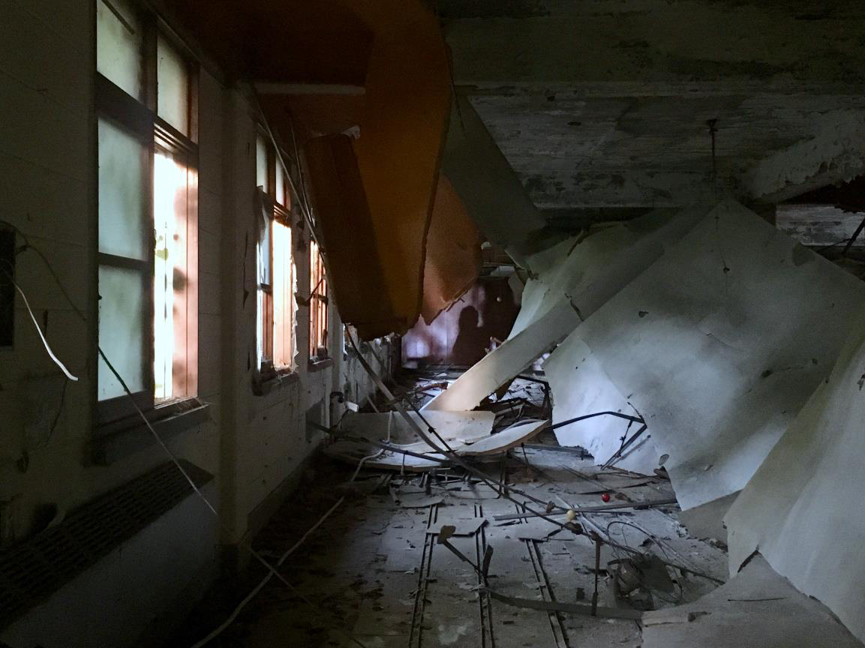

Apichatpong Weerasethakul, *Constellations* (detail), 2018. (Photograph by the author)

*“Constellations”*, which combines moving images and mechanical installations, produces, by means of manipulating light and shade and objects, a range of dreamlike scenes: the billiard ball which suddenly starts rolling by itself, the screen in the projection room which automatically moves up and down, the indistinct specks of light flickering outside the window, silhouettes of people floating on the distant screen… These blend together perfectly with the surrounding environment, enveloping the viewer in their midst, creating a truly transcendental effect. Here Apichatpong is seeking to recreate the context, by means of capturing ‘afterimages’ of Gwangju in that era. In terms of the Gwangju ‘incident’, we did not live through it ourselves, yet it feels as though we have experienced it. The artist has transplanted his subtle treatment of memory and illusion to this hospital, transforming it into an immersive art space. This has finally broken away from the sense of alienation, or of kitsch, which is so common in many art exhibitions or ‘white cube’ art spaces. It has thus allowed me to see how art can reconnect history and the present, how it can create feelings, how it can reawaken the power of the past — and then build on this power to question, challenge or guide current transformations.